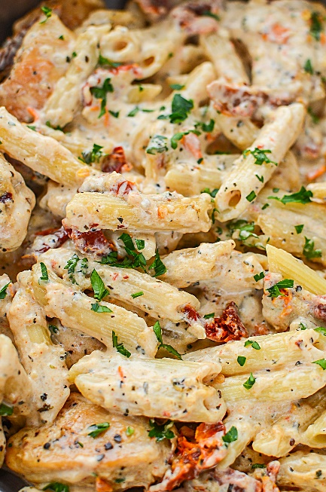
Sundried Tomato Chicken Pasta
Prep time 15 min Cook time 20 min
6 Servings

Ingredients
16 oz pasta
1 lb. boneless skinless chicken
½ tsp salt
½ tsp pepper
1 tsp onion powder
1 tsp adobo
1 tsp paprika
5 garlic cloves, minced
7 oz jar sundried tomatoes
½ cup whole milk
1 cup heavy cream
1 tbsp basil
1 tsp red pepper flakes
1½ cup shredded mozzarella cheese
½ cup beef broth
Directions
- Cut the chicken into 1 inch cubes. Season the chicken with salt, pepper, onion powder, adobo and paprika and set aside.
- In a large skillet, cook the garlic in oil from the sundried tomatoes for about 30 seconds or until fragrant on medium high heat. Then add the chicken and cook for 3 to 4 minutes per side or until cooked through.
- Cut the tomatoes into bite sized pieces and add them to the skillet. Cook for an additional 2 minutes.
- Cook pasta according to package directions.
- In a saucepan, mix the milk, heavy cream, basil, red pepper flakes, mozzarella cheese and broth. Bring to a light boil, mixing constantly.
- Mix the sauce and chicken. Serve over pasta.

